EGR-125, C++ Programming for Engineers
Lab: Using Selection

Linear Equations

Write a program that reads values for the coefficients A, B, C, D, E, and F of the equations

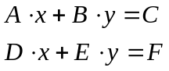

of two straight lines, and then determine whether the lines are parallel (their slopes are equal) or the lines intersect. If they intersect, determine whether the lines are perpendicular (the product of their slopes is equal to -1).

Hint: Take care when comparing two real numbers using a computer, you don’t always get what you expect. Did you read and understand the material discussing “Comparing the equality of two real numbers” in your text book?

Try these equations:

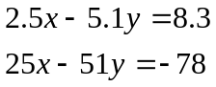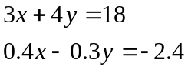

Extra Credit: Try finding the intersection point of the non-parallel lines, or make your program repeat for more equations than just two. Can your program handle some zero coefficients?

